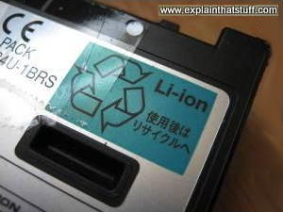
How lithium-ion batteries work

Photo: Lithium-ion (Li-ion) batteries are less environmentally damaging than batteries containing heavy metals such as cadmium and mercury, but recycling them is still far preferable to incinerating them or sending them to landfill.
Like any other battery, a rechargeable lithium-ion battery is made of one or more power-generating compartments called cells. Each cell has essentially three components: a positive electrode (connected to the battery's positive or + terminal), a negative electrode (connected to the negative or − terminal), and a chemical called an electrolyte in between them. The positive electrode is typically made from a chemical compound called lithium-cobalt oxide (LiCoO2) or, in newer batteries, from lithium iron phosphate (LiFePO4). The negative electrode is generally made from carbon (graphite) and the electrolyte varies from one type of battery to another—but isn't too important in understanding the basic idea of how the battery works.
All lithium-ion batteries work in broadly the same way. When the battery is charging up, the lithium-cobalt oxide, positive electrode gives up some of its lithium ions, which move through the electrolyte to the negative, graphite electrode and remain there. The battery takes in and stores energy during this process. When the battery is discharging, the lithium ions move back across the electrolyte to the positive electrode, producing the energy that powers the battery. In both cases, electrons flow in the opposite direction to the ions around the outer circuit. Electrons do not flow through the electrolyte: it's effectively an insulating barrier, so far as electrons are concerned.
The movement of ions (through the electrolyte) and electrons (around the external circuit, in the opposite direction) are interconnected processes, and if either stops so does the other. If ions stop moving through the electrolyte because the battery completely discharges, electrons can't move through the outer circuit either—so you lose your power. Similarly, if you switch off whatever the battery is powering, the flow of electrons stops and so does the flow of ions. The battery essentially stops discharging at a high rate (but it does keep on discharging, at a very slow rate, even with the appliance disconnected).
Unlike simpler batteries, lithium-ion ones have built in electronic controllers that regulate how they charge and discharge. They prevent the overcharging and overheating that can cause lithium-ion batteries to explode in some circumstances.

