Form AB1: Assignment Front Sheet
Qualification |  |  |  | Unit number and title
L3 Subsidiary Diploma in Electrical/Electronic Engineering |  |  |  | Unit 4: Mathematics for Engineering Technicians
Learner name |  |  |  | Assessor name
Date issued |  |  | Hand in deadline |  | Submitted on
Assignment title |  | Assignment 2: Trigonometry and Mensuration
In this assessment you will have opportunities to provide evidence against the following criteria.
Indicate the page numbers where the evidence can be found.
Criteria reference | To achieve the criteria the evidence must show that the learner is able to: |  |  |  |  |  | Task no. |  | Evidence  Page number
P4 | solve circular and triangular measurement problems involving the use of radian, sine, cosine and tangent functions |  |  |  |  |  | 1a, b, c
P5 | sketch each of the three trigonometric functions over a complete cycle |  |  |  |  |  | 2
P6 | produce answers to two practical engineering problems involving the sine and cosine rule |  |  |  |  |  | 3a, b
P7 | use standard formulae to find surface areas and volumes of regular solids for three different examples respectively |  |  |  |  |  | 4
Learner declaration
I certify that the work submitted for this assignment is my own. I have clearly referenced any sources used in the work. I understand that false declaration is a form of malpractice.

Learner signature: Date:
Purpose of this assignment:

You will use trigonometric and mensuration techniques to solve engineering problems
Task 1
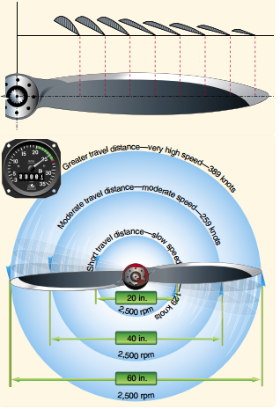
- A technician carried out a test on a propeller and established that it turned through 2500 revolutions in a minute. What was the average angular velocity of the propeller in radians per second?
- At each of the positions listed (20in, 40in, 60in) convert these into meters and work out the distance travelled by each of the markers on the propeller (in meters) after a 3 minute engine test at a constant angular velocity (as calculated from the previous question).

(Hint, do this in a table format)
This provides evidence for [P4 ]
Task 1c
- Calculate the area and arc length of the major sector of the 60 mm diameter circle shown below.
- A horizontal milling machine is fitted with a 100 mm diameter plain cutter. What speed should the cutter be set at to achieve a cutting speed of 0.8 ms⁻¹?

- A force of 60kN is applied at an angle of 70° to a horizontal datum. Calculate the vertical and horizontal components of the force.

- In a manufacturing cell the last turning operation is parting off a component for a car gearbox. The parting tool is fed into the work piece with a force of 300 N and the vertical load on the tool tip is 575 N.

Calculate the resultant of the two forces and the angle at which it acts to the horizontal

This provides evidence for [P4]
Task 2

For angles in the range θ = 0° to 360° and working in steps of 30° tabulate values for
    - sin θ,
    - cos θ and
    - tan θ
Sketch these out on graph paper. (Print out your own graph paper!) – draw and label these graphs
This provides evidence for [P5]
Task 3
You work in the design department of a company which produces fabricated steel
structures and have been given sketches of two frames. For each, work out the lengths of all the members and the angles involved.

3a The roof frame shown below is symmetrical about a centre line axis.

3b Part of a lifting device is shown in the diagram opposite. The longest member is called a tie bar and is angled at 70° to the horizontal. The other long member is called the strut and is angled at 80° to the horizontal. The length of the base is 1.4 m.

This provides evidence for [P6]
Task 4
Consider a standard Ice cream cone – and one of your choice flavours of ice cream
Such that the diameter of the ice cream cone is set to be 5cm, which is the same as the diameter of the perfectly spherical scoop of ice cream.

5cm
5cm
10cm

- When the ice cream is placed onto the cone what is the space left unfilled with ice cream?

- I had this idea of completely dipping the whole cone and ice cream into chocolate - if the optimum thickness is 2mm – what volume of chocolate do I use on a cone if the complete outside is to be covered with chocolate of thickness 2mm

This provides evidence for [P7]
Evidence checklist
[Summarise evidence required, e.g. ‘leaflet’, ‘presentation notes’ etc.] |  |  |  |  |  |  |  |  |  | [tick boxes]
Calculations
Graphs

