Metal:
Metals account for about two thirds of all the elements and about 24% of the mass of the planet. They are all around us in such forms as steel structures, copper wires, aluminium foil, and gold jewellery. Metals are widely used because of their properties: strength, ductility, high melting point, thermal and electrical conductivity, and toughness.
These properties also offer clues as to the structure of metals. As with all elements, metals are composed of atoms. The strength of metals suggests that these atoms are held together by strong bonds. These bonds must also allow atoms to move; otherwise how could metals be hammered into sheets or drawn into wires? A reasonable model would be one in which atoms are held together by strong, but delocalized, bonds.
Bonding
Such bonds could be formed between metal atoms that have low electronegativities and do not attract their valence electrons strongly. This would allow the outermost electrons to be shared by all the surrounding atoms, resulting in positive ions (cations) surrounded by a sea of electrons (sometimes referred to as an electron cloud).

Figure 1: Metallic Bonding.

Because these valence electrons are shared by all the atoms, they are not considered to be associated with any one atom. This is very different from ionic or covalent bonds, where electrons are held by one or two atoms. The metallic bond is therefore strong and uniform. Since electrons are attracted to many atoms, they have considerable mobility that allows for the good heat and electrical conductivity seen in metals.

Above their melting point, metals are liquids, and their atoms are randomly arranged and relatively free to move. However, when cooled below their melting point, metals rearrange to form ordered, crystalline structures.
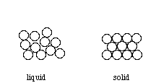
Figure 2: Arrangement of atoms in a liquid and a solid.
Crystals

To form the strongest metallic bonds, metals are packed together as closely as possible. Several packing arrangements are possible. Instead of atoms, imagine marbles that need to be packed in a box. The marbles would be placed on the bottom of the box in neat orderly rows and then a second layer begun. The second layer of marbles cannot be placed directly on top of the other marbles and so the rows of marbles in this layer move into the spaces between marbles in the first layer. The first layer of marbles can be designated as A and the second layer as B giving the two layers a designation of AB.
 | 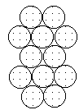 | 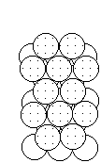

Processing:

In industry, molten metal is cooled to form the solid. The solid metal is then mechanically shaped to form a particular product. How (the rate of change of temperature and the pressures applied) these steps are carried out is very important because heat and plastic deformation can strongly affect the mechanical properties of a metal.

Grain Size Effect:

It has long been known that the properties of some metals could be changed by heat treating. Grains in metals tend to grow larger as the metal is heated. A grain can grow larger by atoms migrating from another grain that may eventually disappear. Dislocations cannot cross grain boundaries easily, so the size of grains determines how easily the dislocations can move. As expected, metals with small grains are stronger but they are less ductile. Figure 5 shows an example of the grain structure of metals.
Quenching and Hardening:
There are many ways in which metals can be heat treated. Annealing is a softening process in which metals are heated and then allowed to cool slowly. Most steels may be hardened by heating and quenching (cooling rapidly). This process was used quite early in the history of processing steel. In fact, it was believed that biological fluids made the best quenching liquids and urine was sometimes used. In some ancient civilizations, the red hot sword blades were sometimes plunged into the bodies of hapless prisoners! Today metals are quenched in water or oil. Actually, quenching in salt water solutions is faster, so the ancients were not entirely wrong.
Quenching results in a metal that is very hard but also brittle. Gently heating a hardened metal and allowing it to cool slowly will produce a metal that is still hard but also less brittle. This process is known as tempering. (See Processing Metals Activity). It results in many small Fe₃C precipitates in the steel, which block dislocation motion which thereby provide the strengthening.
Cold Working:
Because plastic deformation results from the movement of dislocations, metals can be strengthened by preventing this motion. When a metal is bent or shaped, dislocations are generated and move. As the number of dislocations in the crystal increases, they will get tangled or pinned and will not be able to move. This will strengthen the metal, making it harder to deform. This process is known as cold working. At higher temperatures the dislocations can rearrange, so little strengthening occurs.
You can try this with a paper clip. Unbend the paper clip and bend one of the straight sections back and forth several times. Imagine what is occurring on the atomic level. Notice that it is more difficult to bend the metal at the same place. Dislocations have formed and become tangled, increasing the strength. The paper clip will eventually break at the bend. Cold working obviously only works to a certain extent! Too much deformation results in a tangle of dislocations that are unable to move, so the metal breaks instead.
Heating removes the effects of cold-working. When cold worked metals are heated, recrystallization occurs. New grains form and grow to consume the cold worked portion. The new grains have fewer dislocations and the original properties are restored.

Deformation:

When small loads (stresses) are applied to metals they deform, and they return to their original shape when the load is released. Bending a sheet of steel is an example where the bonds are bent or stretched only a small percentage. This is called elastic deformation and involves temporary stretching or bending of bonds between atoms.
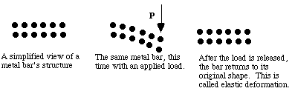

Figure 7: Elastic deformation in a bar of metal.

When higher stresses are applied, permanent (plastic) deformation occurs. For example, when a paper clip is bent a large amount and then released, it will remain partially bent. This plastic deformation involves the breaking of bonds, often by the motion of dislocations. See Figure 8. Dislocations move easily in metals, due to the delocalized bonding, but do not move easily in ceramics. This largely explains why metals are ductile, while ceramics are brittle.

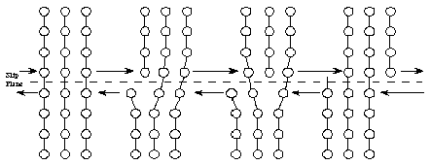
Figure 8: Dislocation movement in a crystal.

If placed under too large of a stress, metals will mechanically fail, or fracture. This can also result over time from many small stresses. The most common reason (about 80%) for metal failure is fatigue. Through the application and release of small stresses (as many as millions of times) as the metal is used, small cracks in the metal are formed and grow slowly. Eventually the metal is permanently deformed or it breaks (fractures).

