TASKS TO BE COMPLETED AND ASSESSMENT CRITERIA

Task 1

Determine the magnitude and direction of the resultant force and turning moment about point A for the system of forces acting on the bridge support plate shown opposite. What would be the equilibrant force?
3 m
F₁ = 8 KN
F₂ = 10 KN
F₄ = 6 KN
F₃ = 30 KN
A
30º
135º
4 m

Task 2
UDL = 2 KN/m
2.75 m
1m
10 KN
8 KN
0.75m
R₁
R₂

Determine the support reactions for the roof beam shown opposite. The UDL is across the whole length of the beam.

Task

The rectangular steel bar opposite is part of a static test rig and extends under a tensile load of 28KN. If the elastic modulus for the steel is 208 GN/m², calculate:

  - The stress in the bar
  - The resulting strain
  - The extension of the bar.

Task

Ø16 mm rivets are being used to hold together the sides of a storage vessel and are subject to the loading shown. Calculate:

  - The resulting shear stress
  - The resulting shear strain if the shear modulus for the rivet material is 80GN/m².

Task

The diagram opposite shows the section through part of a car trailer and the corresponding loading. The failure criteria for the Ø12 mm high tensile bolt shown is:

30 KN

12 KN

UTS = 540MN/m²
τ_{MAX} = 320MN/m²

Calculate the maximum permissible factor of safety for the working conditions detailed.

Task

A connecting plate, which links the members in an Engineering structure, is acted upon by four coplanar non concurrent forces as shown in Fig. 1.1 below:

Determine:

1.1 the magnitude and sense of the resultant force

1.2 the magnitude and direction of the equlibrant force
1.3 the perpendicular distance of the line of action of the resultant force from the corner A at which the 1 kN force acts.

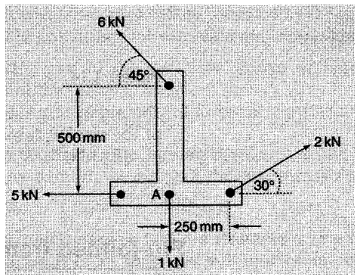

Task

Determine the reactions at the supports (A and B) for the bridge system shown in the figure below. The bridge has a uniform distributed load (UDL) of 3 kNm⁻¹.

[P2a]

1 m 2 m 1 m

A B

25 kN 6 kN

R_{A} R_{B}

Fig. 2.1

Task

A horizontal shaft is simply supported in a bearing at point A and B, 3 m apart with two point loads. The weight of the beam is 2 kNm⁻¹.

Determine the reactions forces R_{A} and R_{B} of the bearings at the supports as shown in the figure below

[P2b]

8 kN 3 kN

1.5 m 1.5 m 1.0 m

A B

R_{A} R_{B}

Fig. 2.2

Task

A tie steel rod in shown below has a diameter 12 mm and length of 2 m carries an axial load of 20 kN. The Modulus of elasticity of the material is 150 GPa.

Determine:

  - the tensile stress induced in the material [P3a]

  - the tensile strain in the material [P3b]

  - the change in length [P3c]

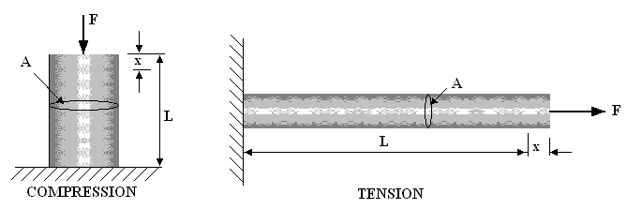

Task

A rectangular pin joint 30 mm x 15 mm x 10 mm is used to join two steel rods under shear force deforms in shape as shown in below.

F= 15 kN

x = 0.02 mm

15 mm
10 mm

30 mm F = 15 kN
Fig. 2
Determine:

2.1 the shear stress [P3d]

2.2 the shear strain [P3e]

Task

Determine the magnitude, direction and sense of the resultant force and turning moment about point A for the system of forces acting on the sheet metal part shown opposite. The part is 5m x 4m with a 3m x 2m section machine off as shown What would be the equilibrant force? Show the force and sense on the diagram.

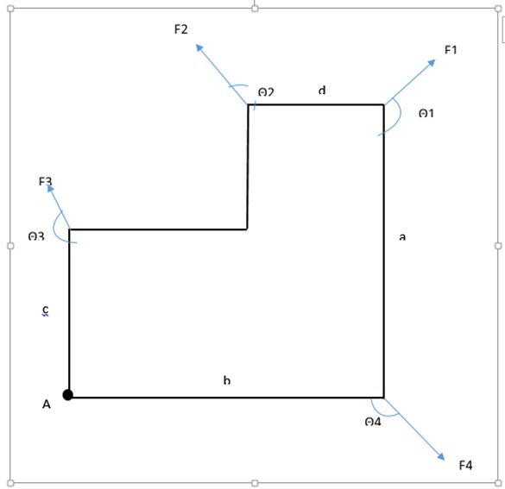

 | 0 | 1 | 2 | 3 | 4 | 5 | 6 | 7 | 8 | 9
F1(KN) | 5.5 | 3.5 | 2.5 | 2.8 | 3.2 | 2.9 | 4.5 | 3.8 | 3.5 | 4.2
F2(KN) | 4 | 4 | 3 | 3.6 | 3.3 | 3.7 | 3.2 | 2.7 | 3 | 3.5
F3(KN) | 3.5 | 5 | 4 | 2.4 | 4.2 | 2.8 | 2.7 | 3 | 5 | 2.8
F4(KN) | 3 | 4.5 | 5 | 4 | 3.5 | 3 | 3.6 | 2.6 | 4.2 | 3
Θ1(º) | 135 | 120 | 150 | 145 | 150 | 135 | 120 | 150 | 140 | 135
Θ2(º) | 160 | 135 | 120 | 150 | `145 | 140 | 150 | 145 | 150 | 120
Θ3(º) | 120 | 150 | 145 | 135 | 120 | 150 | 135 | 120 | 145 | 150
Θ4(º) | 150 | 140 | 135 | 120 | 130 | 125 | 145 | 135 | 135 | 140

Task

State the conditions of static equilibrium.

Determine the support reactions for the simply supported beam shown below, if the length of the beam is 12m and weight is 15KN The UDL is between load F1 and F2.

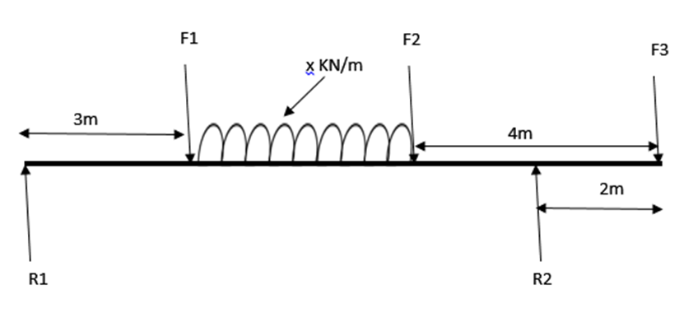

 | 0 | 1 | 2 | 3 | 4 | 5 | 6 | 7 | 8 | 9
F1(KN) | 25 | 22 | 27 | 30 | 21 | 25 | 30 | 26 | 28 | 30
F2(KN) | 30 | 25 | 23 | 20 | 27 | 20 | 22 | 25 | 22 | 25
F3 (KN) | 15 | 30 | 25 | 28 | 25 | 30 | 27 | 23 | 30 | 25
x (KN/m) | 5 | 4 | 3.5 | 4.5 | 3.3 | 4.2 | 2.8 | 3.7 | 4.3 | 3.8

Task

A circular tie rod 25cm long has a diameter of 14mm and extends 0.15mm under a load of 22KN, determine
a) The stress
b) The strain
c) The modulus of elasticity, E, of the steel material from which the tie rod is made.

Task

A rivet has a diameter of 20mm and holds three metal plates together as shown below. Determine the shear stress that the rivet is subjected to. If the shear modulus is 108GN/m², determine the shear stain.

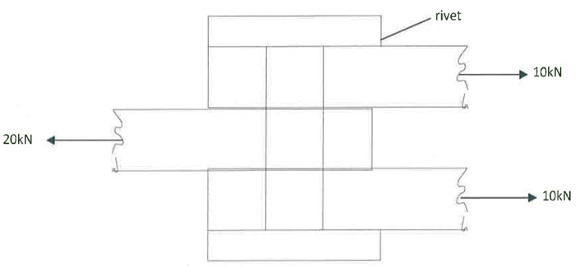

Task

Determine the magnitude, direction and sense of the resultant and equilibrant forces acting on the above component and the perpendicular distance of their line of action from the point A.

Task

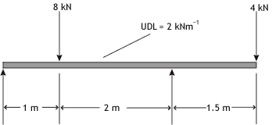

Determine the support reactions for the above simply supported beam.

Task
i) A tie bar of length 2.5 m and diameter 10 mm carries an axial load of 12 kN. The modulus of elasticity of the bar material is 180 GPa. Determine the induced tensile stress, the tensile strain and the change in length that occurs.
ii) The block of material shown below has a shear modulus of 50 GPa. Determine the shear stress and the shear strain induced by the 2 kN shearing force.

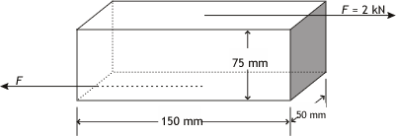

Task

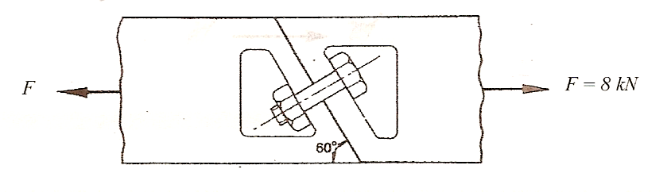
The material for the bolt shown in the angled joint above has an ultimate tensile strength of 500 MPa and a shear strength of 300 MPa. The diameter of the bolt is 8 mm. Determine the factor of safety in operation.

Task

An 80mm diameter hole is to be punched out of a metal plate with a shear strength of 160MPa using a force of 20kN. Determine the maximum thickness of metal plate.

Task

In an experiment to determine the modulus of elasticity of a 1.3mm diameter steel wire, a 1m length sample is loaded, and the corresponding extension is noted. The results of the experiment are as shown below:
Force (N) | 50 | 100 | 150 | 200 | 250 | 300 | 350
Extension (mm) | 0.20 | 0.36 | 0.56 | 0.74 | 0.94 | 1.40 | 1.60
Draw a load versus extension graph and determine the modulus of elasticity of the sample.

Task

A test to determine the force versus extension graph for a specimen of copper gave the following results:
Force (kN) | 5 | 10 | 15 | 20 | 25 | 30 | 35
Extension (mm) | 0.020 | 0.050 | 0.070 | 0.095 | 0.120 | 0.145 | 0.220
The effective length of the specimen is 75mm and it has a cross-sectional area of 150mm². Calculate the modulus of elasticity and the stress at the limit of proportionality.

