FORM AB1: BTEC ASSIGNMENT BRIEF  QCF ASSIGNMENT FRONT SHEET | 

Qualification |  |  | Unit number and title
Level 3 BTEC Subsidiary Diploma in Electrical and Electronic Engineering |  |  | Unit 10 Properties and Applications of Engineering Materials
Learner name |  |  | Assessor name
Jordan Joven |  |  | Jim Gillain
Date issued |  | Hand in deadline |  | Submitted on
w/c 9th May |  | w/c 23 May
Assignment title | The effect of processing on properties: information sources and selection of materials.
Criteria reference | To achieve the criteria the evidence must show that the learner is able to: |  |  |  |  | Task no. |  | Evidence Page No.
P4 | Describe the effects on the properties and behaviour of processing metals, polymers, ceramics and composites and of post-production use of smart materials |  |  |  |  | 2
P5 | Use information sources to select a different material for two given applications, describing the criteria considered in the selection process |  |  |  |  | 1
M1 | Explain how the properties and structure of different given engineering materials affect their behaviour in given engineering applications |  |  |  |  | 3
D1 | Justify your selection of an engineering material for one given application describing the reasons the selection meets the criteria |  |  |  |  | 4
Learner declaration
I certify that the work submitted for this assignment is my own. I have clearly referenced any sources used in the work. I understand that false declaration is a form of malpractice.

Student signature: Date: 23/05/2016
Scenario

You are nearing the end of the first year of an engineering apprenticeship and have been moved into the design department of your company to gain further experience. Part of your new job will involve assisting with the selection of materials when design proposals are being developed into final solutions suitable for prototype manufacture. You will be working with a senior designer and a manufacturing engineer. The chief designer wants to check out your knowledge of engineering materials by giving you a test. To prove what you know about engineering materials you should complete the following tasks.
Task 1

For the following use relevant data sources, including relevant standards and investigate a range of engineering materials that could be used for each of:

- A company that produces products for the outdoor leisure market is designing a new range of barbecues. One half of the barbecue will be a liquefied petroleum gas (LPG) grill and the other half a traditional charcoal burner.

- A computer manufacturer is adding to its PC laptop range by producing a ‘budget’ model for the rapidly expanding 9 to 13-year-old school-learner market. The company’s marketing department have done research and tell the designers that the traditional black or silver casing colour favoured by most business users will not be popular with children and suggest a more colourful approach. You may assume the PC is electrically screened ready to go into the case you describe.

The selected materials must be different and when working through your options you should take account of design, cost and availability criteria.

Include evidence (e.g., screenshots or copies of relevant pages used) to confirm that you identified and examined data sources.

[This task provides evidence for P5]
Task 2
- Making reference to two specific metallic materials, describe what effects the following processes will have on their properties and behaviour in service:
- Recrystallisation
- hot or cold working
- alloying
- Making reference to two specific thermoplastic polymeric materials, describe what effects the following aspects of processing will have on their properties and behaviour in service:
- polymer processing temperature
- other appropriate process parameters (such as mould temperature, injection pressure, injection speed, mould clamping force, mould open and closed time)
- Making reference to two specific thermosetting polymeric materials, describe what effects any one of the following aspects of processing will have on their properties and behaviour in service:
- mould temperature
- moulding pressure and time
- curing temperature and time
- Making reference to two specific ceramic materials, describe what effects any one of the following aspects of processing will have on their properties and behaviour in service:
- water content of clay
- sintering press force
- firing temperature
- Making reference to two specific composite materials, describe what effects the following aspects of processing will have on their properties and behaviour in service:
- fibre alignment
- de-lamination
- matrix/reinforcement ratio
- particle dispersion in cermets
[This task provides evidence for P4]
Task 3

- Plain carbon steel (mild steel) is widely used in the construction of ships hulls. It is easy to work with, low cost and has good structural integrity when ships are operating in normal water temperatures (3°C to 25°C). Explain what happens to the material if a ship is operated for long periods of time in water temperatures that are at or near to freezing.
- Aluminium alloy (code 2024 age hardened, also called Duralumin) is widely used in the construction of passenger aircraft. Explain why this is and the reasons for putting a finite life on certain parts of the airframe.
- The Hep2O® push fit plumbing system uses fittings and pipe work manufactured from polybutylene (PB). Making reference to its properties and structure explain why this material is an effective substitute for traditional copper and brass.
- Machinery such as farm equipment and packaging machines uses shear pins made from high carbon steel to prevent overload if something becomes jammed. Explain the reasons for choosing this material.
- Titanium alloy (code Ti-6Al-2Sn-4Zr-6Mo) is widely used for aircraft engine components and chemical plant equipment. Explain why it performs well in conditions of high stress and high temperature.

For every answer you must explain how the properties and structure of the material affect its performance.

[This task provides evidence for M1]
Task 2

Write a 500-word review in which you justify your choice of material for task 1 (1), giving reasons why other materials initially considered were not selected. Describe the reasons why the chosen material your meets specific criteria relating to the performance/operation of the product.

[This task provides evidence for D1]
Evidence checklist: [e.g. ‘leaflet’, ‘presentation notes’ etc.]

Unit 10 Assignment 2
Task 1
Medium Carbon Steel
http://direct.asda.com/Uniflame-Big-American-Gas-Charcoal-Barbecue-Grill/001699082,default,pd.html
In that link, it contains a charcoal burner and also has a liquefied petroleum gas. The grills made out medium carbon steel has much better properties then steel, as it’s stronger and stiffer and its ability to withstand very high temperatures, up to 2700 degrees Fahrenheit meaning the material is very fit for this purpose. Medium carbon steel also has properties of ductility, being able to stretch while still being strong is an advantage when being used for the grill. Using the process of annealing can greatly increase the properties of the material to be more useful and long lasting, this barbecue grill was designed ergonomically with easily removable parts and shelves for the outdoor leisure use.
The benefits of investing in a barbecue grill made of medium carbon steel is that its long lasting, saves the use of replacing a grill often, saving materials and money, its wear resistant due to the steel property within the grill. Alloying chromium with steel allows properties of ductility and more strength and stainless properties to occur. This also makes it very easy to maintain and aesthetically pleasing to the customer.
Stainless properties also includes corrosion resistant, allowing the grill to resist chemical wear, making it long lasting, it also helps resist rusting to a certain extent. A duel fuel grill can be very convenient for customers who use this product regularly making it very cost affective.
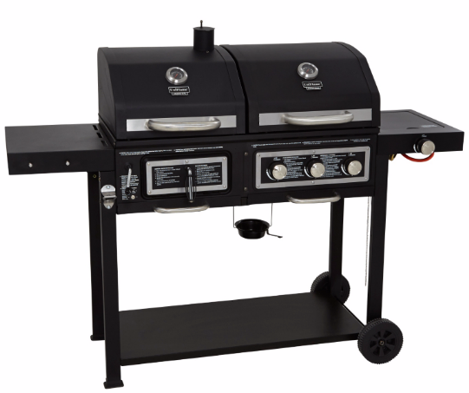

Task 2
Recrystallization:
This process is when deformed crystallites within the structure of a material are replaced with newer sets of grains creating a newer structure for the material.
Allows recovery process by reduction or removal of work-hardening effects (stresses). Increases Equiaxed ferrite grains formed from the elongated grains. Decreases the strength and hardness level. Increases ductility.
Hot or cold working:
Hot/Cold working is to expose the metalwork to a specific high temperature then following it up by a low temperature in order to recrystallize the material.
Alloying:
When another element is combined with another to gain an alloy that has much more useful desired properties for everyday use.
Medium carbon steel can be recrystallized or annealed which is the same process, the internal structure can be returned by exposing the material to temperatures of 550 degrees Celsius, which is later to be soaked in cold water, to carry out Hot/Cold working to recrystallize the steel to its original structure. Using cold working for medium carbon steel allows more useful properties to be created such as hardness and stiffness making the material a lot more useful for various conditions like car body panels.
Alloying aluminium gives the element much stronger properties and having copper cold worked and used with aluminium increases the tensile strength, and the strength to weight ratio, making it very useful for aircraft parts.
Injection Moulding:
The process is where the material in solid form are made into pellets, then loaded into a hopper on top of the injection equipment. The pellets are then heated to turn the material into a viscous state, which in turn moves to the end of the cylinder. Then the molten plastic is injected into the mould.
Flash:
Flash is a defect/waste that is created when a thin layer of the plastic flows outside the peripheral where the two halves of the injection mould would come together.
When high temperatures are applied to HDPE through the moulding process, the material is prone to defects such as blistering where the finish of the end product is altered incorrectly making the end product result ‘bad’ and not desirable to the manufacturers. When the injection speed is too slow, the polymer within the injection equipment would cool down too quickly creating another defect affecting the strength properties and the long chain polymers wouldn’t be aligned as it will come out with wave like patterns.
When polypropylene undergoes the process of injection moulding, there is a chance where burn marks are created affecting the surface of the finished product, also affecting the use as it will not be very good in terms of wearing off. Flash occurs when the clamp for the mould is low, this allows the polypropylene to produce excess material meaning the material has to go through more processes to get rid of the flash.
Compression Moulding:
This is where heat and pressure is applied within an open mould; when material is placed within the mould and added pressure and heat help make the end product.
Thermosetting Process:
While a material is heated (one time only) it moulds into the desired shape and becomes irreversible.
Transfer Moulding:
The process of moulding material which is softened through preheating the material then moved to a closed heated mould forcefully.
Phenol Formaldehyde uses compression moulding where the piece of the plastic is placed into the mould and a hydraulic press moves down to where the piece of plastic is, then the plastic is compressed to the shape of the mould. Properties of phenol formaldehyde is the fact it cannot be reshaped when heated so it is commonly used within the production of circuit boards as they won’t catch fire or melt the inside of the product.
Melamine Formaldehyde this material goes under transfer moulding which gains really good properties such as extreme hardness, colourability preferences which is really useful when marketing the final product since the product can be personalised, additionally the product can be well kept with its hard capabilities.
Ceramic: Made of clay and can be permanently hardened by applying heat to the material.
Porcelain is a known as a ceramic material, water was used to separate the molecules within the clay allowing a plasticity property to be formed within the mould. Then the porcelain goes under the process of firing where the water is taken out and chemical bonds are made between the layers of the material. The drawbacks is that the porcelain won’t be able to return to its original form because it is a thermosetting material.
Cermet is produced through the process sintering, which the particles of fired clay and metal are mixed and compressed in dies. The compression force has to be a certain amount to make the mixture take up the shape of the die cavity and also produce cold welds between the metal particles so that when firing takes place, grain growth occurs across the boundaries of these welds. Properties of cermet is that it’s very hard and tough moreover this material can be used in conditions where temperatures are high.
De-lamination:
A process forming a mica-like structure of separate layers with significant loss of mechanical toughness. This occurs under stress and which in turn splits the resin plastics, like epoxy into different layers.
Reinforcement ratio:
It’s the amount of steel to concrete, can be used to calculate them in structures such as pillars, arches. It’s used to make sure the ratio is correct to ensure the correct balance.
Particle Dispersion:
This is when particle being dispersed in a continuous phase of different composition onto a certain material, in the case of cermet’s. It is normally the ceramic being sprayed with molten metals to combine them for better properties, high heat resistance and high strength.
Epoxy Resin can be reinforced using glass fibres. Fibre alignment can be used to do so. The alignment of the fibres will affect which way the material bends, or this can even make the material not able to bend by randomly placing the fibres in all directions to make sure it doesn’t bend.
Task 3
1)
Plain carbon steel or also be called mild steel is widely using in the construction of ship hulls. Properties can include ductility and malleability, it can be reshaped without breaking and undergo stress to deform its original shape. It’s low cost and has good structural integrity when ships are operating in normal water temperatures.
When in cold water that is near freezing, plain carbon steel loses some of its properties while gaining new properties. As its near freezing, the plain carbon steel becomes brittle losing the ductility of the metal meaning that if put under a great stress in a short amount of time, the ship hull, plain carbon steel would snap. Cold shortness is often the process.
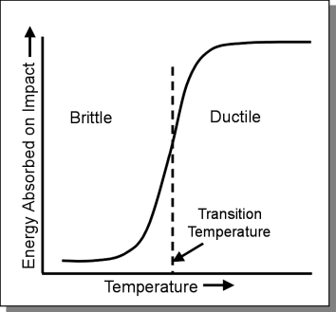

2.
Duralumin is an aluminium alloy widely used in the construction of passenger aircraft. This is due to its great strength to density ratio making it ideal when trying to reduce the aircrafts weight to achieve efficiency. Some of the properties of duralumin include being lightweight, ductile and malleable and a good conductor in heat and electricity. However, even though duralumin is the ideal material for aircrafts, a finite lifetime is put in place for health and safety reasons, this is due to the wearing down of the material through continuous use. Duralumin has the finite lifetime of around 10 years in aircraft construction because the metal is put under a lot of stress and the metals structural integrity will weaken or develop cracks that can’t be seen with the naked eye, so reduce any accidents, it has a finite lifetime.
3.
Polybutylene is used for fittings and pipe work due to its properties being well adjusted for this type of construction. Properties are; easy to weld, temperature resistant, flexible and a high hydrostatic pressure resistance.
Flexibility allows the material to be shaped and formed without breaking, making it convenient, and very similar to copper and brass. However the material is temperature resistant meaning the material can withstand relatively low and high temperatures without affecting the shape of the pipe or fitting. This is extremely useful because it’s a relatively cheap material. In addition the property that makes Polybutylene really favourable for pipes because it can resist high hydrostatic pressure, it’s very popular in the plumbing field as a lot of fluid passes through the pipe, this is very necessary as you don’t want to be constantly replacing pipes because they got worn down by water pressure.
Copper and brass don’t have much of the same properties, and both are more expensive and can’t do the same job as well as Polybutylene. The drawbacks to copper is that it suffers from water acidity and it will wear down, making the copper pipes inefficient, and on the other the hand the drawback to brass is that it goes through the process of dezincification where the zinc oxidises creating a white powder, this causes clogs in the pipes and fixtures.
4.
High carbon steel is used to make shear pins, this helps prevent overloads when the piece of machinery becomes jammed/ obstructed and mainly found within farm equipment and packaging machines. High carbon steel is very strong but quite brittle, this is a benefit as that they can only endure a certain amount of stress before they shear off. This benefits machinery as it would prevent it from further damage then if it was a tough pin where it took extreme amount of stress and further destroying the whole machine. Shear pins allow the machine to be used over and over again and also easily repairable.
5.
Titanium alloy is used for aircraft engine components as wells as chemical plant equipment. Titanium alloy withstands high stress and temperature when in use, as in an aircraft engine it would be working for hours, and it preforms really well, it’s has a low weight and very ideal for its use because aircrafts need to be as light as they can when travelling to not use as much fuel when travelling. The alloy is really strong and also resistant to high temperatures.
Titanium alloy has a hexagonal close-packed structure however when a certain temperature is reached, normally high, the crystalline temperature converts to a body-centred cubic structure, and when under high stress the alloy still keeps the strength property constant. When under high strain the alloy becomes very flexible and performs really well still. The fact that Titanium Alloys are very good to dissipating heat ensuring that the alloy itself has a low thermal conductivity.
Task 4
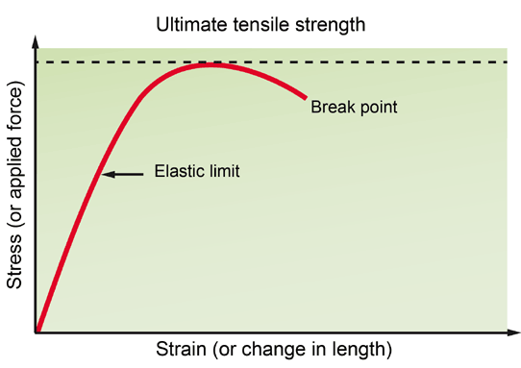
Medium carbon steel has between 0.3 and 0.7 percent carbon added during manufacturing, it has high tensile strength meaning the medium carbon steel can resist amount a high amount of tensile stress before breaking. To make this specific range of carbon steel, the carbon is combined with a process of quenching (cooling the steel from the outer surface to the inner) and tempering to create a structure that has a consistent tensile strength (referred to as martensite) throughout the body. The tensile strength makes the grill strong so it can’t endure being used and hold the structure of the grill together.
Medium carbon steel has excellent thermal conductivity and heat retention properties, it takes a lot less energy to keep it at temperature. The reason it’s used for the grill is because it can withstand very high temperatures, up to 2700 degrees Fahrenheit. This is extremely high, and sometimes the grill won’t even come close to the maximum temperature. When using a charcoal grill you can’t control the heat as much and the temperature wouldn’t remain constant so a high temperature resistant material is needed so the product is useful and doesn’t melt.
Aluminium can’t be used for grills because it’s soft and not particularly strong and relatively expensive and won’t be fit for purpose. Comparing it to the medium carbon steel, it doesn’t have the same amount of strength and normally aluminium is better alloyed. Medium carbon is an alloy, containing many desirable and ideal properties perfect for a barbecue grill.
Titanium was also an option for the grill however its very costly and laborious processes are needed to extract it from its various ores. However titanium is corrosion resistant, making it long lasting and has the highest strength-to-density ratio of any metallic element. Unalloyed it’s as strong as some steels but less dense. Its relatively high melting point (more than 1650 degrees Celsius) makes it very useful for refractory metal. However the reason I didn’t choose titanium even though it’s favourable, the reason is because it will only be used for outdoor leisure, nothing beneficiary.
Medium carbon is the perfect substitute because it’s easily obtainable and due to its ductility and malleability it can shaped and stretched into the shape for the barbecue easily during manufacturing, it saves time in creating the barbecues out of medium carbon steel.
Stainless steel barbecues were also an option, because of its durability and ease to use. Also resistant to corrosion and rust, and has a nice clean finish. This is very appealing to customers as they normally leave the barbecues outside after use, this exposes the barbecue to the natural elements but the barbecue is resistant to it. On the other hand medium carbon steel has stainless steel properties but just alloyed with carbon, making it so much more advantageous with high melting points and more properties that make it very ideal for the use of the grill.
All the properties of medium carbon steel, contribute to a very high performance and long lasting lifespan of the product.

